**WEEK 04**

1. ***Find out the maximum and minimum salary from the employee table.***

SELECT MAX(salary) AS max_salary, MIN(salary) AS min_salary FROM employee;

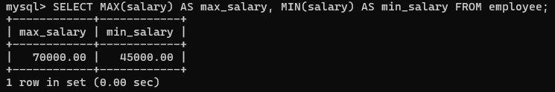

1. ***Show the total salary and average salary of all the employees.***

SELECT SUM(salary) AS total_salary, AVG(salary) AS average_salary FROM employee;

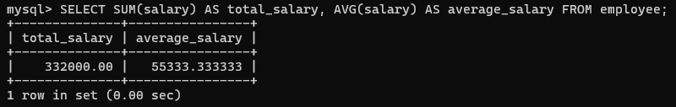

1. ***Show all the details of the employees who have the same salary.***

Insert into employee (EmployeeId, name, department, salary, age, city)

values (7, 'John Foe', 'HR', 60000, 30, "New York");

SELECT salary, COUNT(salary) AS salary_count FROM employee GROUP BY salary HAVING COUNT(salary) > 1;

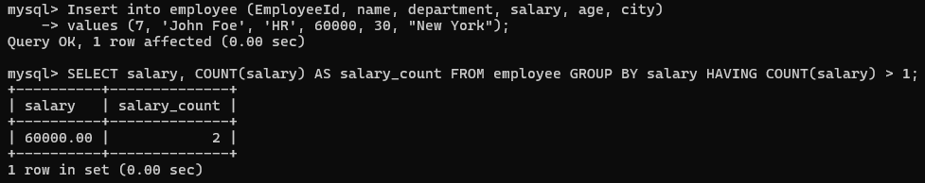

1. ***Display the employees name from lowest salary to the highest salary.***

SELECT name FROM employee ORDER BY salary ASC;

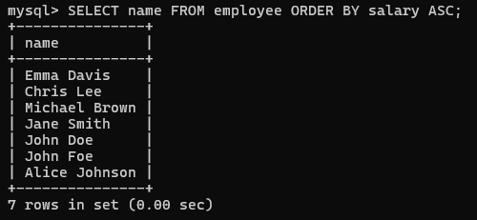

1. ***Display the employee name and salary (department-wise) for employees, whose salary is greater than or equal to 10,000 and age is greater than 25.***

SELECT department, name, salary FROM employee

WHERE salary >= 10000 AND age > 25 ORDER BY department, salary;

